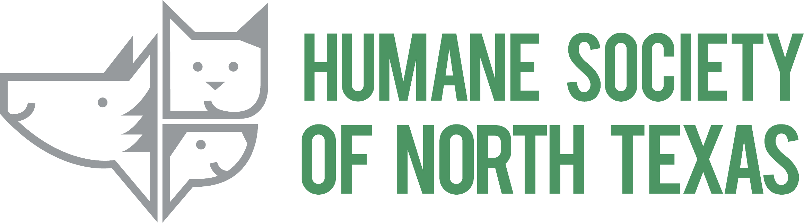
Cassie Davidson
Director of Communications, Marketing, & Public Relations Humane Society of North Texas Cell: (817) 909-0667
Email: CDavidson@hsnt.org
FOR IMMIATE RELEASE

Check Pet Adoption Off Your Holiday List
By Attending the MEGA Adoption Event!

The Humane Society of North Texas and the Fort Worth Animal Shelter Host the MEGA Adoption Event to Save a Thousand Pets’ Lives!

Fort Worth, Texas, December 16th, 2021:
The Humane Society of North Texas (HSNT) is excited to announce that, for the fifth time in four consecutive years, it will partner with the Fort Worth Animal Shelter to host a 2-day MEGA Adoption Event on Saturday and Sunday, December 18th & 19th, from 10 a.m.– 6 p.m. at the Will Rogers Memorial Center, Cattle Barn #1! This event is proudly supported by Petco Love and BOBS from Skechers. Admission to the event is free; parking fees may vary.

The goal of the MEGA Adoption Event is to find homes for over 1,000 amazing pets, just in time for the holidays! Come find the dog, puppy, cat, kitten, or small animal of your dreams! The adoption fee for all pets is only $10. All adoptable dogs and cats have been spayed or neutered, microchipped, and received rabies and age-appropriate vaccinations. Every dog or cat adopter will receive a free initial veterinary visit (with a participating local vet) and a 30-day trial of pet insurance.

Be first in line to adopt! HSNT will be offering an Early Bird Fast Pass, which will allow the first 100 registered participants early admission from 9-10 a.m. on Saturday, December 18th. Visit hsnt.org/MEGA to register for the Early Bird Fast Pass – each pass entitles the holder to adopt one pet. HSNT highly recommends purchasing the Early Bird Fast Pass if you are interested in adopting a puppy as they are always in high demand. The cost is $50 and does not include the $10 adoption fee.

The MEGA Adoption Event will kick-off with a City of Forth Worth Police Department escort for the “Parade of Pets” from HSNT’s main shelter located at 1840 E. Lancaster Ave., Fort Worth, Texas, 76103, on Friday, December 17th at 1:00 p.m. The procession of HSNT and City vehicles, adoption trailers and vans will travel down Lancaster Avenue until they arrive at Will Rogers Memorial Center, Cattle Barn #1, located at 3401 Burnett-Tandy Drive, Fort Worth, Texas, 76107.

“There are so many pets in our shelters needing forever homes right now,” said Cassie Davidson, Director of Communications, Marketing & Public Relations at HSNT. “The Humane Society of North Texas is excited to host the MEGA Adoption Event and spread some Yuletide joy this season.”

Due to the movement of all adoptable animals to prepare for the MEGA Adoption Event, all HSNT adoption centers will be closed Friday, Saturday and Sunday, December 17th, 18th & 19th, as animals are transported to, and adopted at, the MEGA Adoption Event. All pet adoptions will take place at the MEGA Adoption Event on December 18th & 19th.

- HSNT’s animal intake for owner surrenders, strays at 1840 E. Lancaster Ave., Fort Worth, Texas, 76103, will be open Friday, Saturday, and Sunday, December 17th, 18th, & 19th.
- HSNT’s public clinic for spay/neuter surgeries and humane euthanasia at 2309 Chester St., Fort Worth, Texas, 76103 will be open Friday and Saturday, December 17th & 18th.

Please visit hsnt.org/MEGA or Facebook for more information about the MEGA Adoption Event.

About the Humane Society of North Texas
Since 1905, the Humane Society of North Texas (HSNT) has worked to eliminate animal cruelty, promote humane values and end animal homelessness in North Texas. As an independent nonprofit organization, HSNT relies on the generosity of the public to help ensure there is a safe place for abused, injured, and homeless animals in the community. To make a lifesaving donation, please visit hsnt.org/donate or Facebook. To learn more about HSNT, visit hsnt.org, Facebook, Twitter, TikTok and Instagram. Pets and People, Saving Each Other™

About Fort Worth Animal Care & Control
The City of Fort Worth Animal Care & Control (FWACC) balances a number of goals – to manage animal shelter operations, offer animal adoption centers, host spay/neuter and low-cost vaccination clinics, enforcement and public education and outreach. The goal is to reduce the number of stray animals in the city, minimize the threat of diseases, such as rabies, and offer compassionate care to every pet that lands on its doorstep. FWACC works in partnership with community volunteers, businesses and rescue organizations to ensure every pet finds a loving and forever home.

About Petco Love
Petco Love is a nonprofit organization that changes lives by making communities and pet families closer, stronger, and healthier. Since our founding in 1999 as the Petco Foundation, we’ve empowered animal welfare organizations by investing $300 million in adoption and other lifesaving efforts. We’ve helped find loving homes for more than 6.5 million pets in partnership with Petco and organizations nationwide. Today, our love for pets drives us to lead with innovation, creating tools animal lovers need to reunite lost pets, and lead with passion, inspiring and mobilizing communities and our more than 4,000 animal welfare partners to drive lifesaving change alongside us. Is love calling you? Visit petcolove.org or follow at Facebook, Instagram, Twitter, and LinkedIn to be part of the lifesaving work we’re leading every day.

About BOBS from Skechers
BOBS from Skechers’ charitable collection of shoes, apparel and accessories have improved animals’ lives: over the past five years, Skechers has contributed more than $7.3 million to help more than 1.4 million shelter pets, including saving more than a million rescued pets in the United States and Canada. It all started in 2011, when Skechers launched a movement to support children impacted by natural disasters and poverty – a cause that has helped the Company donate more than 16 million new pairs of shoes to kids in more than 60 countries worldwide. To learn more about BOBS from Skechers’ commitment to making a difference, visit BOBSfromSkechers.com and follow the brand on Facebook, Instagram and Twitter.

###

